Name : Adwait Shelare PRN : 25070521169
7.1.2 Possible combinations of three digit
ALGORITHM
Step 1: Start
Step 2: Read a, b, c
Step 3: digits ← [a, b, c]
Step 4: For i = 0 to 2
For j = 0 to 2
For k = 0 to 2
If i ≠ j AND j ≠ k AND i ≠ k
Display digits[i]digits[j]digits[k]
Step 5: Stop
Flowchart
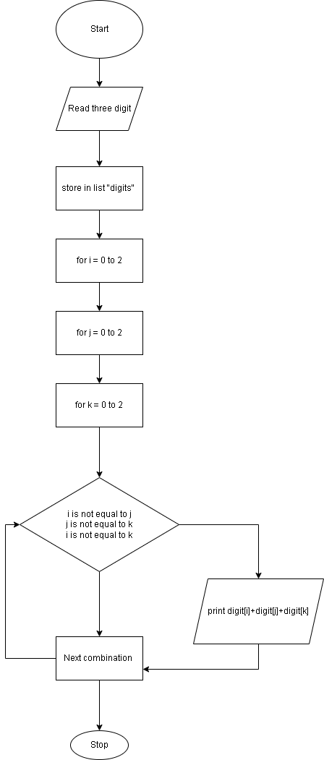

Python Code
# Read three space-separated digits
digits = input().split()

# Generate all possible 3-digit combinations using each digit exactly once
for i in range(3):
for j in range(3):
for k in range(3):
if i != j and j != k and i != k:
print(digits[i] + digits[j] + digits[k])
EXCECUTION

